In this method, there is no criteria check before the file is written:

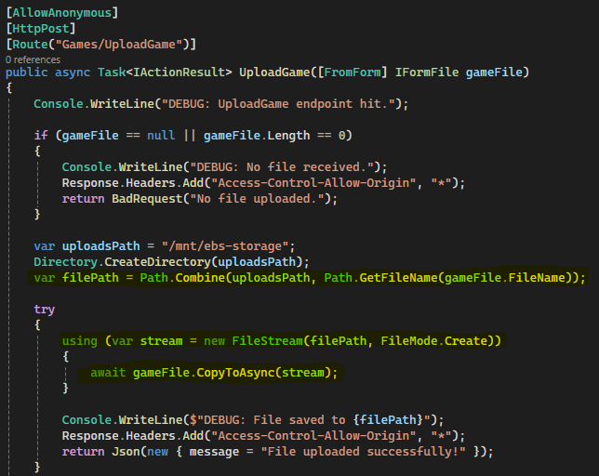

It’s saved immediately, even if it’s invalid. We need to have the criteria check happen prior to saving. We could write the validation logic as a separate method or even a service class so that we can simply call something like “GameCriteriaService.Validate(gamefile)”